An Adaptive Energy-Aware Clustering Algorithm for Lifetime Maximization in Homogeneous Wireless Sensor Networks

Ishaq A. Idris*
Sokoto Energy Research Center, Energy Commission of Nigeria, Usmanu Danfodiyo University, Sokoto, Nigeria
E-mail: iaishaq@energy.gov.ng
ORCID ID: https://orcid.org/0000-0001-8449-7744
*Corresponding Author

Abdulkarim Bello
Department of Computer Science, Usmanu Danfodiyo University, Sokoto, Nigeria
E-mail: bello.abdulkarim@udusok.edu.ng
ORCID ID: https://orcid.org/0009-0002-6239-9195

Abubakar B. Tambawal
Department of Computer Science, Umaru Ali Shinkafi Polytechnic, Sokoto, Nigeria
E-mail: us.tamba@gmail.com
ORCID ID: https://orcid.org/0009-0007-2867-9309

Samaila Buda
Physics Depatment, Usmanu Danfodiyo University, Sokoto, Nigeria
E-mail: samaila.buda@udusok.edu.ng
ORCID ID: https://orcid.org/0000-0002-0584-3918

Received: 26 February, 2026; Revised: 04 March, 2026; Accepted: 14 March, 2026; Published: 08 April, 2026

Abstract: Wireless Sensor Networks have emerged as a key technology enabling real time data collection and monitoring across various domains, including environmental monitoring, industrial control, healthcare, and security applications. However, despite their growing relevance, energy efficiency remains a fundamental design challenge due to the limited power supply of sensor nodes, which directly impacts overall network lifetime and reliability. This paper proposes an Adaptive Energy-Aware Clustering Protocol (EACP) designed to improve energy efficiency and extend the operational lifetime of homogeneous WSNs. The proposed protocol integrates three main mechanisms: Residual Energy-based Cluster Head Selection, to ensure balanced energy distribution; Mobility-Aware Cluster Head Reassignment, to maintain stable communication under node mobility; and Base Station Proximity Based Direct Transmission, which allows nodes near the BS to bypass CHs, thereby minimizing redundant energy use. These mechanisms allow the network to dynamically adapt to changing energy conditions and communication distances. The protocol was evaluated through extensive MATLAB simulations and compared with benchmark protocols including LEACH, HAC, and HSA. Simulation results demonstrate that the proposed EACP significantly improves network performance. Specifically, it achieves 50% to 94% improvement in network lifetime, reduces energy consumption by approximately 20% to 25%, and increases throughput by more than 2.5 times compared to the benchmark protocols. These results demonstrate that EACP offers a scalable, energy-efficient communication strategy well suited for large scale WSNs deployments.

Index Terms: Wireless Sensor Networks, Energy Efficiency, Clustering, Routing Protocols, Network Lifetime, Mobility-Aware Communication.

1. Introduction
In today’s digital world, wireless technologies have become indispensable for communication and data exchange. The proliferation of portable devices such as smartphones, tablets, and laptops has accelerated the development of Wireless Sensor Networks (WSNs), which are capable of autonomously monitoring, sensing, and transmitting environmental data without relying on fixed infrastructure [1,33]. WSNs consist of spatially distributed sensor nodes that communicate wirelessly and cooperate to perform sensing tasks such as environmental monitoring, disaster management, healthcare, and defense surveillance [2,3]. Each sensor node is equipped with a processing unit, transceiver, and limited energy supply typically a battery making energy efficiency a critical design consideration for network sustainability [4,14].
To address energy constraints, clustering based routing has emerged as a key strategy. In clustering, nodes are grouped into clusters, and a Cluster Head (CH) is selected to aggregate and forward data from member nodes to the Base Station (BS). This reduces redundant transmissions and extends network lifetime [5,6]. A pioneering contribution in this domain is the Low-Energy Adaptive Clustering Hierarchy (LEACH) protocol proposed [7], which introduced a hierarchical structure to minimize energy consumption. However, its random CH selection mechanism often disregards residual node energy, leading to uneven energy depletion and premature node deaths [8]. Subsequent enhancements, including LEACH-Centralized (LEACH-C) and Distributed Cluster Head Selection (LEACH-DCHS), attempted to improve energy balance by incorporating BS coordination and residual energy considerations [8,9]. Other notable schemes, such as Hierarchical Agglomerative Clustering (HAC) [10] and Hybrid Spectral-based Algorithms (HSA) [11], achieved further energy optimization but introduced computational complexity and poor adaptability to dynamic or mobile environments. Moreover, many of these protocols assume static topologies, which limit their applicability in real-world IoT or mobile WSN scenarios where node movement and topology changes are frequent [12,13].
Despite the significant progress made in clustering based routing protocols for Wireless Sensor Networks, several important challenges remain unresolved. Many existing protocols focus primarily on residual energy during cluster head selection but do not simultaneously consider communication distance, node density, and dynamic network conditions. Additionally, most traditional clustering algorithms assume static network topologies and fixed clustering structures, which limits their adaptability in environments where nodes may change communication conditions or where energy levels vary significantly over time. Another limitation observed in existing protocols is the inefficient routing of data from nodes located near the base station, where unnecessary cluster-based transmission introduces additional energy overhead [16,15].
Furthermore, several clustering approaches rely on complex optimization techniques or centralized coordination mechanisms that increase computational overhead and may not be suitable for resource constrained sensor nodes [17,18]. As a result, there remains a need for an adaptive clustering protocol that can balance energy consumption, reduce redundant communication, and dynamically adjust cluster structures based on both energy availability and network topology. Recent studies have increasingly focused on advanced optimization techniques to enhance energy efficiency and scalability in Wireless Sensor Networks. In particular, hybrid clustering approaches that integrate swarm intelligence and metaheuristic optimization algorithms have demonstrated significant improvements in energy balancing and cluster head selection efficiency [30,32]. Furthermore, recent works have explored machine learning assisted and intelligent networking mechanisms, such as graph neural network based routing and adaptive sensor configuration, to dynamically optimize network performance under varying conditions [34,35]. Moreover, recent routing and energy management strategies, including multi-hop routing optimization and on-demand energy replenishment techniques, have been proposed to further improve network lifetime and scalability in dense deployments [36,37]. These developments highlight a growing trend toward intelligent and optimization driven routing strategies for large scale WSN applications.
Furthermore, recent works have also explore Cross-layer design approaches, such as dynamic contention window adaptation, have demonstrated improved energy utilization in dense network environments by optimizing medium access control and reducing communication overhead [38]. Additionally, multi-objective optimization techniques have been proposed to balance coverage and energy consumption in complex and heterogeneous deployments, thereby improving overall network performance [39].
In addition, energy efficient node scheduling strategies have been introduced to manage redundant nodes and minimize unnecessary transmissions, significantly extending network lifetime [40]. Recent advances also incorporate intelligent and learning based techniques, including deep reinforcement learning and graph neural networks, to dynamically evaluate and enhance network reliability under varying operational conditions [41]. These developments highlight a shift toward adaptive, intelligent, and optimization driven solutions for large scale WSNs. The proposed Energy-Aware Clustering Protocol (EACP) aligns with this direction by incorporating adaptive clustering, mobility-aware mechanisms, and energy-aware decision processes to enhance overall network performance.
To overcome these challenges, this study proposes an Adaptive Energy-Aware Clustering Protocol (EACP) that integrates three key mechanisms: (1) Residual Energy-Based CH Selection, which ensures energy-balanced clustering; (2) Mobility-Aware CH Reassignment, which dynamically adjusts node to cluster associations in mobile environments; and (3) BS Proximity Direct Transmission, allowing nodes near the BS to bypass CHs and transmit directly to BS. This adaptive framework reduces communication overhead, minimizes redundant transmissions, and significantly prolongs network lifetime across various deployment scales.
The proposed EACP is designed for both static and mobile WSN environments, enabling reliable performance in diverse applications such as smart cities, healthcare monitoring, intelligent transportation, and environmental sensing. By integrating energy awareness with adaptive transmission mechanisms, the proposed protocol addresses the limitations of traditional clustering approaches and contributes to the development of scalable, energy efficient, and sustainable wireless sensor networks.

1.1. Contributions of the Proposed Work
Several clustering protocols have been proposed to improve the energy efficiency of Wireless Sensor Networks (WSNs), many existing approaches either rely on static clustering mechanisms or consider only limited parameters during cluster head (CH) selection. Furthermore, most traditional clustering schemes do not adequately address dynamic network conditions such as node mobility, uneven energy distribution, and inefficient routing for nodes located close to the base station.
To address these limitations, this study proposes an Adaptive Energy-Aware Clustering Protocol (EACP) designed to improve network lifetime and energy efficiency through a multi criteria and adaptive clustering mechanism.
The main contributions of this work are summarized as follows:

- Multi Parameter Cluster Head Selection:
Unlike traditional protocols that rely primarily on residual energy, the proposed EACP integrates residual energy, distance to the base station, and average neighbor distance into a weighted scoring model to achieve balanced cluster head selection and improved network stability.
- Mobility-Aware Cluster Head Reassignment:
The proposed protocol dynamically allows nodes to switch to alternative cluster heads when better communication conditions are detected, thereby reducing packet loss and improving communication reliability in dynamic network environments.
- Base Station Proximity Based Direct Transmission:
Nodes located within a threshold distance from the base station can transmit data directly without routing through cluster heads, thereby reducing redundant communication overhead and conserving energy.
- Adaptive Cluster Formation:
Unlike fixed clustering mechanisms, EACP dynamically adjusts the number and distribution of cluster heads in each round based on node energy levels and spatial distribution.
- Improved Network Performance:
Simulation results demonstrate that the proposed EACP significantly improves residual energy conservation, network lifetime, and throughput compared to benchmark protocols such as LEACH, HAC, and HSA.

2. Related Works
In this section, several clustering based routing protocols for Wireless Sensor Networks (WSNs) are reviewed, focusing on their mechanisms, strengths, and limitations in terms of energy efficiency, scalability, and adaptability.
Early research on low power systems for micro sensors was pioneered by [17], who presented an energy conservation framework based on Micro-Electronic Systems (MEMS). Their study identified partitioning as a means to optimize energy utilization; however, inconsistencies in partitioning methods limited applicability to conventional WSN architectures. Similarly, [18] introduced design considerations for distributed micro-sensor systems, emphasizing scalability and reliable data transmission. Although their work addressed energy dissipation and latency, scalability and energy management challenges persisted. The work proposed by [7] Low Energy Adaptive Clustering Hierarchy (LEACH) protocol, one of the earliest hierarchical routing protocols designed to minimize energy consumption through periodic clustering. LEACH operates in rounds, comprising setup and steady-state phases where cluster heads (CHs) are randomly selected. Although this randomization balances energy dissipation, it overlooks residual energy, leading to inefficient CH selection and reduced network lifetime. Subsequently, [8] introduced LEACH-Centralized (LEACH-C), in which the Base Station (BS) centrally selects CHs based on residual energy. While this centralized approach improved energy efficiency, it occasionally chose low-energy nodes as CHs, compromising longevity. [19] Proposed Distributed Cluster Head Selection (LEACH-DCHS), incorporating residual energy into CH election. Although this modification extended network lifetime, its conservative threshold approach sometimes prevented optimal clustering even when nodes retained adequate energy levels. [5] Refined CH selection with Improved LEACH (I-LEACH) by preventing recently selected CHs from being re-elected in consecutive rounds, thereby reducing energy depletion. However, this modification caused uneven CH distribution, increasing energy usage in certain regions. Reference [20] improved upon this by dynamically adjusting CH election thresholds based on network conditions, achieving better load balancing but at the cost of higher computational overhead. Reference [21] proposed the Energy-Efficient Clustering Scheme (EECS), a competition-based approach that selects CHs according to node residual energy and probability factors. While EECS enhanced fairness in CH selection, its control overhead reduced scalability in dense networks. Likewise, [22] developed the Cluster based Multi-hop Routing Protocol (CMRP), which considered three selection factors for CH election. However, when neighbor density dropped below an optimal threshold, CH selection became infeasible. Reference [23] later proposed an Energy Efficient and Balanced Clustering approach using residual energy, one-hop information, and node density. Although it achieved balanced CH distribution, excessive retransmissions in dense deployments limited its efficiency. Reference [24] introduced a multi-layer clustering scheme to adapt to varying network densities and energy levels, enhancing scalability. However, the protocol generated high control message overhead, impacting efficiency. Similarly, [25] improved CH selection using combined parameters such as residual energy, node density, and BS proximity. While this improved throughput and network lifetime, frequent re-clustering and excessive control packets remained problematic. Reference [26] later proposed the Dynamic Weight-Based Clustering Algorithm (DWCA), employing weighted parameters to balance energy and load. Although effective, the high control packet exchange limited its scalability for large WSNs. Reference [27] focused on mobile WSNs and proposed adaptive clustering algorithms tailored for dynamic environments, improving energy efficiency and network adaptability. However, frequent topology changes still posed challenges to maintaining stable energy consumption. Reference [28] proposed a multi-criteria CH selection framework incorporating environmental and network parameters to enhance energy efficiency and reliability, but the algorithm’s computational complexity limited its suitability for real-time scenarios. Reference [29] analyzed clustering schemes in heterogeneous WSNs, identifying trade-offs among scalability, energy efficiency, and CH distribution. Their study emphasized the need for clustering algorithms capable of adapting dynamically to mobile and heterogeneous network conditions. Reference [30] introduced an energy-balancing protocol using kernel density estimation and multiple CHs, which extended network lifetime but exhibited poor scalability in mobile environments. Reference [31] proposed an energy-efficient cluster routing scheme integrating a map-diminution-based optimization algorithm for intrusion detection. Despite improving security, this approach imposed significant system complexity on resource-limited nodes. Reference [32] presented a hybrid ABC-ACO clustering algorithm that conserves energy through bio-inspired optimization. However, the complexity of parameter tuning, such as pheromone evaporation and bee population control, limited implementation feasibility. Reference [11] combined HSA with LEACH to optimize CH selection and extend network lifetime. Nevertheless, the approach lacked comparative evaluation against established protocols and showed poor adaptability in mobile environments. Reference [10] proposed a Hierarchical Agglomerative Clustering (HAC)-based routing protocol to improve scalability and lifetime. While successful in static networks, it suffered from high computational cost and limited flexibility in heterogeneous and mobile conditions. From the reviewed literature, it can be observed that saveral clustering based routing protocols have been proposed to improve energy efficiency and network lifetime in Wireless Sensor Networks. Many approaches focus on optimizing cluster head selection using parameters such as residual energy, node density, and distance to the base station. While these methods have shown improvements in network performance, several limitations remain.
First, many traditional protocols such as LEACH and its variants rely on probabilistic or partially centralized cluster head selection mechanisms, which may result in uneven energy consumption and unstable cluster structures. Second, several advanced clustering algorithms employ complex optimization techniques that increase computational overhead and reduce their suitability for resource constrained sensor nodes. Third, most existing protocols assume static network conditions and do not adequately address dynamic communication scenarios where nodes may experience changing connectivity or mobility.
Furthermore, only a limited number of studies consider the inefficiency of routing data through cluster heads when nodes are located close to the base station. This can lead to unnecessary communication overhead and faster energy depletion in dense networks. These limitations highlight the need for a more adaptive clustering protocol capable of balancing energy consumption, reducing redundant transmissions, and dynamically adjusting cluster structures based on real-time network conditions. The proposed Energy-Aware Clustering Protocol (EACP) addresses these challenges by integrating multi parameter cluster head selection, mobility-aware cluster reassignment, and base station proximity based direct transmission.

3. Proposed Approach
The performance of the proposed Adaptive Energy-Aware Clustering Protocol (EACP) was evaluated through MATLAB based simulations. A wireless sensor network consisting of randomly deployed sensor nodes was considered within a square sensing field. The first order radio energy model was used to simulate the energy consumption of sensor nodes during transmission and reception. The proposed protocol was compared with benchmark clustering protocols including LEACH, HAC, and HSA under identical simulation conditions. The key simulation parameters used in the experiments are summarized in Table 1. The network topology consists of a Base Station (BS) positioned at three different coordinates, specifically (50, 50), (50, 100), and (50, 150), representing varying BS placement scenarios within and outside the sensing field illustrated in Figure 2. For experimentation, 100, 200, and 300 sensor nodes were randomly deployed across a sensing area of 100 × 100 m², as illustrated in Table 1. All nodes were assumed to be homogeneous, having identical sensing, communication, and initial energy capabilities. This setup enables a fair comparison of the proposed EACP’s performance against benchmark protocols under diverse network densities and BS placements.

3.1. Radio Energy Dissipation Model
The energy consumption of EACP is based on the first order radio dissipation model [7] shown in Figure 1, which is widely adopted in Wireless Sensor Network simulations particularly in protocols such as LEACH. In this model, energy is dissipated in two main operations: data transmission and data reception. Additional energy is consumed for data aggregation when performed (e.g., at cluster heads). The energy required to transmit a message over a distance is given by using (1):

 | $${ E}_{Tx}\left(k,d\right)=\left\{\begin{aligned}{kE}_{elec}+{{kε}_{fs}d}^{2} if d<d_{0} \\ {kE}_{elec}+ {{kε}_{mp}d}^{4} if d≥d_{0} \\ \end{aligned}\right\}$$ | (1)

The energy consumed during data reception is calculated using (2):

 | $$E_{Rx}\left(k\right)={kE}_{elec}$$ | (2)

Note that cluster heads also perform data aggregation before forwarding data to the base station which consumes additional energy.

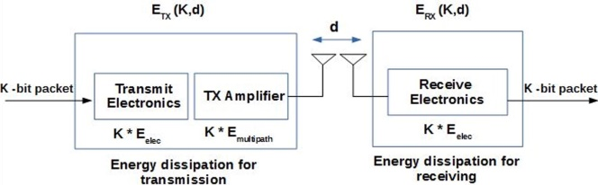
Fig. 1. Network Energy Model

Table 1. Simulation Parameters
Parameter | Value
Network Simulation Area (m × m) | 100m × 100m
Location of Base Station | (50, 50), (50, 100), (50, 150)
Number of Sensor Nodes | 100, 200, 300
Number of Cluster Head | 5,10,15,20,25 and 30
CH Selection Metric | Residual energy, distance to BS, avg neighbor distance
Initial Energy per Node | 0.5 J
Data Packet Size (bits) | 500 bytes
Energy for Transmission (Etx) | 50 nJ/bit
Energy for Reception (Erx) | 50 nJ/bit
Energy Dissipation (EDA) | 5nJ/bit/signal
Amplification Energy (Free Space) | 10 pJ/bit/m²
Amplification Energy (Multipath) | 0.0013 pJ/bit/m⁴
Control Packet Size (bits) | 25 byte
Simulation Runs | 10 (averaged per result)
Radio Model | First Order Radio Model
Environment | MATLAB Simulation

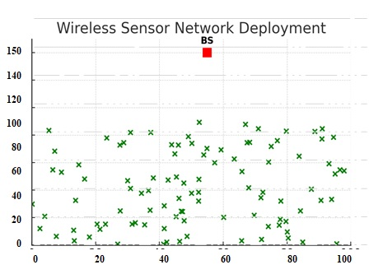
Fig. 2. Network Topology over the 100*100 m (BS x=50, y=150)

3.2. Adaptive Energy-Aware Clustering Protocol to Enhance Wireless Sensor Network Lifetime
The proposed Adaptive Energy-Aware Clustering Protocol (EACP) introduces an adaptive architecture designed to enhance energy efficiency and network lifetime in Wireless Sensor Networks (WSNs) through dynamic communication strategies between sensor nodes and the Base Station (BS). It integrates three key mechanisms: (1) Residual Energy-Based Cluster Head (CH) Selection, which elects CHs using a weighted score combining residual energy, distance to the BS, and proximity to neighboring nodes to ensure balanced energy consumption; (2) Mobility-Aware CH Reassignment, allowing nodes to dynamically switch to nearby CHs with stronger signals or shorter communication distances to minimize packet loss and retransmissions in mobile environments; and (3) BS Proximity Direct Transmission, enabling nodes located within a threshold distance from the BS to bypass CHs and transmit directly, thus reducing unnecessary relay transmissions. Unlike static clustering schemes such as k-means, EACP dynamically forms clusters in each round based on real time parameters including residual energy, signal strength, and hop count to the BS. The number of active CHs, denoted in (3):

 | $$(0≤k≤N)$$ | (3)

is determined adaptively according to node distribution and energy states where k is the number of active CHs in a given round. The protocol assumes a stationary, resource rich BS and evaluates performance under three BS placements central, edge, and outside the sensing field to test adaptability under different routing complexities. Using 4000-bit data packets and smaller control packets, EACP optimizes communication by allowing each node to adopt the most energy-efficient transmission mode, either through its CH, a neighboring CH, or directly to the BS

3.3. Cluster Head (CH) Selection Phase
The selection of cluster heads in the proposed Energy-Aware Clustering protocol (EACP) is based on a weighted scoring mechanism that considers three important parameters: residual energy, distance to the base station (BS), and average distance to neighboring nodes. The cluster head selection score for each node is computed in (4):

 | $${CH}_{−}Score\left(i\right)=w_{1}\left(\frac{E_{residual}}{E_{initial}}\right)+ w_{2}\left(\frac{1}{d_{BS}}\right)+ w_{3} \left(\frac{1}{d_{avg_neigh}}\right)$$ | (4)

The nodes whose residual energy drops below a predefined energy threshold E_{th} are excluded from CH candidacy to prevent premature node death. Among the eligible nodes, the one with the highest score within a localized region declares itself as the CH. If two or more nodes have the same score, the tie is broken randomly. This multi-parameter evaluation ensures that nodes with sufficient energy reserves, favorable proximity to the base station, and balanced neighborhood connectivity are more likely to become cluster heads.

Algorithm 1: EACP Cluster Head Selection Algorithm

Input:
Output:

1:
2:
3:
4: End If
5: End For
6:
7:
8:

3.4. Set up Phase
Once CHs are selected, they broadcast advertisement messages to surrounding nodes. Non-CH nodes listen for these messages and join the cluster of the CH from which they receive the strongest signal strength (RSSI). Each member node informs its chosen CH by sending a join-request message. The CH then allocates a TDMA (Time Division Multiple Access) schedule to its cluster members, allowing them to transmit data in an organized manner and reduce collisions. During non-transmission slots, sensor nodes switch their radios to sleep mode to conserve energy.
CHs aggregate the data received from their members, compress redundant information, and forward the aggregated packets directly to the BS. This aggregation process reduces communication overhead and conserves energy. The CH continues to operate in this role as long as its residual energy remains above the threshold E_{th}. When its energy falls below the threshold, the role is reassigned in the next round following the same selection procedure. This design enables EACP to balance energy usage across the network, reduce unnecessary energy drain, and extend the overall network lifetime compared to existing schemes such as LEACH, HAC, and HSA.

Algorithm 2: EACP Cluster Setup Phase

Input:
Output:

1:
2:
3:
4:
5:
6:
7: End If
8: End For
9:
10: Broadcast CH advertisement to all nodes
11: Each non-CH node sends join-request to the nearest CH
12: CHs create TDMA schedule for their cluster members

3.5. Steady State Phase (EACP)
Once the clusters are formed using the EACP cluster head selection and set-up process, the network enters the steady state phase where data transmission takes place. Member nodes transmit their sensed data to the respective CHs using the allocated TDMA slots, thereby avoiding collisions and conserving energy. Each data packet contains the sensed information, the node ID, and its residual energy.
Upon receiving data from member nodes, the CH performs local data aggregation and compression to minimize redundant information before forwarding it to the Base Station (BS). This step significantly reduces communication overhead, conserves bandwidth, and lowers energy consumption across the network. The CH continues to function as long as its residual energy remains above the defined energy threshold. If a CH’s residual energy falls below this threshold, it reverts to a normal node status, and the next eligible CH based on the scoring function established during the set-up phase is promoted to ensure uninterrupted communication.
This adaptive mechanism ensures that energy consumption is distributed fairly across the network, prolonging the overall network lifetime and preventing premature node death near the BS. After each round, the process repeats with updated energy values, maintaining a balance between efficient data transmission and sustainable energy usage.

Algorithm 3: EACP Steady State Data Transmission Phase

Input:
Output: Aggregated data sent to BS

1: For each TDMA time slot do
2:
3: CH receives data from all members
4: CH aggregates and compresses received data
5: CH transmits aggregated packet directly to BS
6: End For
7:
8:
9: Demote CH to normal node
10:
11: End If
12: Start next round

3.6. Adaptive Energy-Aware Clustering Protocol (EACP) algorithm Pseudo codes

Algorithm 4: Adaptive Energy-Aware Clustering Protocol (EACP)

Input: Sensor nodes deployed in sensing field, Initial energy and Base station location
Output: Energy efficient data transmission and extended network lifetime

Step 1: Network Initialization
- Deploy sensor nodes randomly in the sensing area.
- Initialize each node with initial energy​.
- Broadcast base station location to all nodes.
Step 2: Cluster Head Selection
- For each node compute the cluster head score using the proposed scoring function.
- Evaluate residual energy, distance to base station, and neighbor density.
- Select nodes with the highest score as cluster heads for the current round.
Step 3: Cluster Formation
- Cluster heads broadcast advertisement messages.
- Normal nodes join the nearest cluster head based on signal strength and distance.
- Cluster heads create a TDMA schedule for member nodes.
Step 4: Mobility-Aware Cluster Adjustment
- Nodes monitor communication quality with the current cluster head.
- If a better cluster head becomes available, the node switches to the new cluster head.
Step 5: Data Transmission
- Member nodes transmit sensed data to their cluster heads according to the TDMA schedule.
- Cluster heads aggregate received data.
Step 6: Direct Transmission Near Base Station
- Nodes located within a predefined threshold distance from the base station transmit data directly to the base station.
- This avoids unnecessary routing through cluster heads.
Step 7: Energy Update
Update residual energy of nodes after each transmission round.
- Nodes with depleted energy are marked as dead nodes.
Step 8: Next Round
- Repeat the clustering process until the network reaches the termination condition.

4. Simulation Results
The proposed EACP protocol was implemented and simulated using MATLAB R2019a in order to evaluate the effectiveness of the proposed Energy-Aware Clustering Protocol (EACP), its performance was compared with three well known clustering based routing protocols: LEACH, HAC, and HSA. These protocols were selected because they represent different categories of clustering strategies widely used in Wireless Sensor Network research. LEACH is a classical probabilistic clustering protocol that serves as a benchmark in many WSN studies. HAC introduces adaptive clustering mechanisms to improve energy efficiency, while HSA incorporates optimization based strategies for cluster formation. Although several recent energy efficient routing protocols and optimization based clustering algorithms have been proposed in the literature, many of them involve complex optimization techniques or require centralized computation, which may not be suitable for resource constrained sensor nodes. Therefore, the selected protocols provide a balanced benchmark for evaluating the performance of the proposed approach under comparable network conditions. The network topology utilized for the simulation is illustrated in Figure 1, while the detailed simulation parameters are presented in Table 1. To comprehensively assess performance, several key evaluation metrics were employed, including energy consumption, network lifetime, number of alive/dead nodes, and throughput. These metrics were recorded and compared across three deployment scales 100, 200, and 300 nodes randomly distributed in a 100 × 100 m² sensing field. By analyzing these results, the effectiveness of EACP in extending network lifetime, balancing energy consumption, and improving data delivery reliability is demonstrated relative to LEACH, HAC, and HSA.
Figure 3 to 6 illustrates the residual energy trend of the network over simulation rounds. The proposed protocol maintains higher residual energy compared with LEACH, HAC, and HSA. This improvement can be attributed to the multi parameter cluster head selection mechanism used in the proposed Energy-Aware Clustering Protocol (EACP). Unlike conventional clustering protocols that rely primarily on probabilistic cluster head selection, the proposed approach considers residual energy, distance to the base station, and neighborhood connectivity. As a result, nodes with higher energy reserves and better communication positions are more likely to be selected as cluster heads. This strategy helps distribute energy consumption more evenly across the network and prevents early energy depletion of individual nodes.
Additionally, the direct transmission mechanism for nodes located near the base station reduces unnecessary multi hop communication through cluster heads, thereby lowering overall transmission energy consumption. These factors collectively contribute to the slower energy depletion observed in the proposed protocol.
Furthermore, as illustrated in Figures 3 to 6, the energy gap between the proposed Energy-Aware Clustering Protocol (EACP) and the benchmark protocols becomes more pronounced as the number of deployed nodes increases from 100 to 200 and 300 nodes. This trend indicates that the proposed protocol scales more efficiently in dense network environments compared with traditional clustering approaches such as LEACH, HAC, and HSA.
The improved scalability can be attributed to the multi parameter cluster head selection mechanism employed in EACP, which considers residual energy, communication distance to the base station, and neighborhood density. As the network size grows, this mechanism helps distribute the communication load more evenly among nodes, preventing certain nodes from being overburdened with cluster head responsibilities. In addition, the adaptive clustering strategy reduces redundant transmissions and improves data aggregation efficiency, which becomes increasingly important in high-density deployments. As a result, EACP maintains lower overall energy consumption and slower energy depletion rates as the network size increases.
These results demonstrate that the proposed protocol is capable of maintaining efficient energy utilization even in large-scale wireless sensor networks, confirming its suitability for applications involving dense sensor deployments.

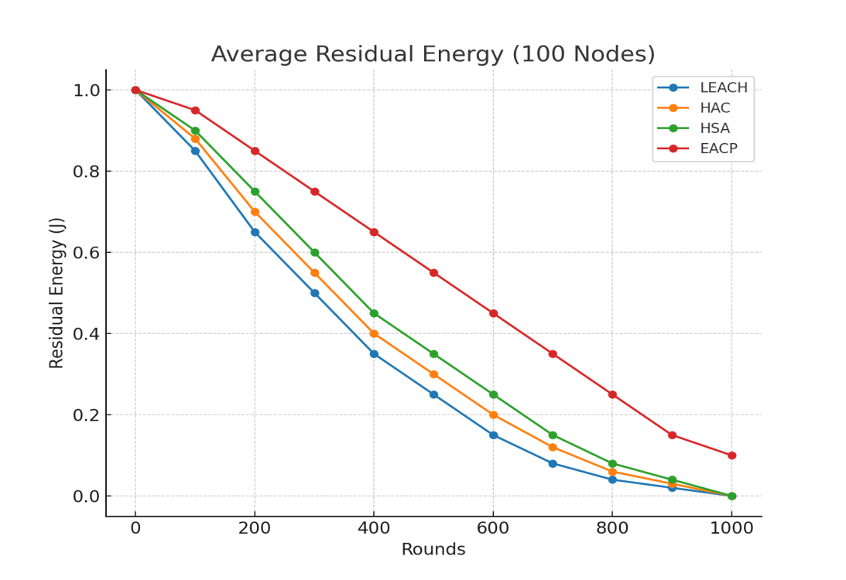
Fig. 3. Residual Energy Comparison for 100 Nodes
Figure 3 presents the variation of average residual energy over simulation rounds, where the number of rounds is represented on the x-axis and the average residual energy of the network is shown on the y-axis. The results indicate that the proposed Energy-Aware Clustering Protocol (EACP) maintains higher residual energy throughout the simulation compared with the benchmark protocols, including LEACH, HAC, and HSA. This slower rate of energy depletion can be attributed to the optimized cluster head selection strategy implemented in EACP, which prioritizes nodes with higher residual energy and favorable communication distances. By distributing cluster head responsibilities among more suitable nodes, the protocol prevents premature exhaustion of individual nodes. In addition, the direct transmission mechanism for nodes located near the base station reduces unnecessary multi-hop communication through cluster heads, thereby minimizing energy consumption during data transmission. As a result, the network preserves a larger portion of its energy resources over time, which ultimately contributes to improved energy efficiency and an extended operational lifetime of the wireless sensor network.

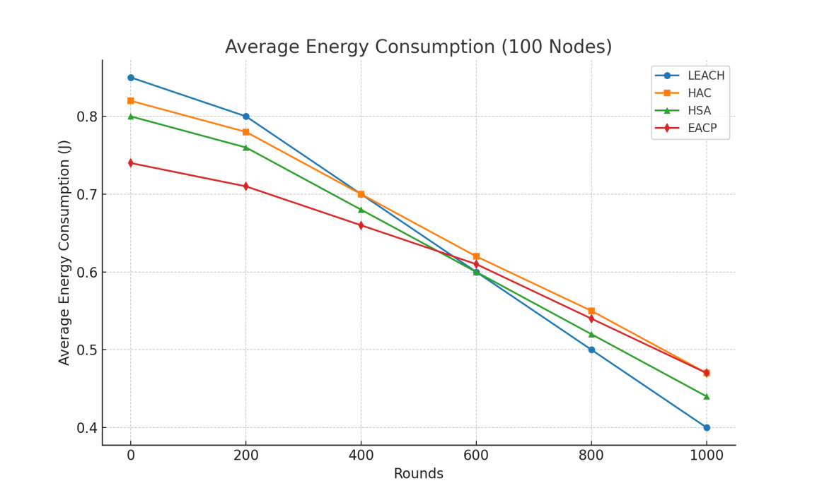
Fig. 4. Average Energy Comparison for 100 Nodes
Figure 4 illustrates the energy consumption trend of the network under the evaluated protocols. The results indicate that the proposed Energy-Aware Clustering Protocol (EACP) consumes less energy compared with LEACH, HAC, and HSA, resulting in a slower rate of overall energy dissipation throughout the simulation period. This improvement is mainly attributed to the optimized cluster head selection mechanism employed in EACP, which considers residual energy and communication distance when selecting cluster heads. By ensuring that nodes with higher energy levels and favorable positions assume cluster head responsibilities, the protocol achieves better load balancing across the network. In addition, the direct transmission mechanism for nodes located near the base station reduces unnecessary routing through cluster heads, thereby minimizing communication overhead and transmission energy consumption. Consequently, the proposed protocol maintains more efficient energy utilization, which contributes to prolonged network stability and an extended operational lifetime of the wireless sensor network.

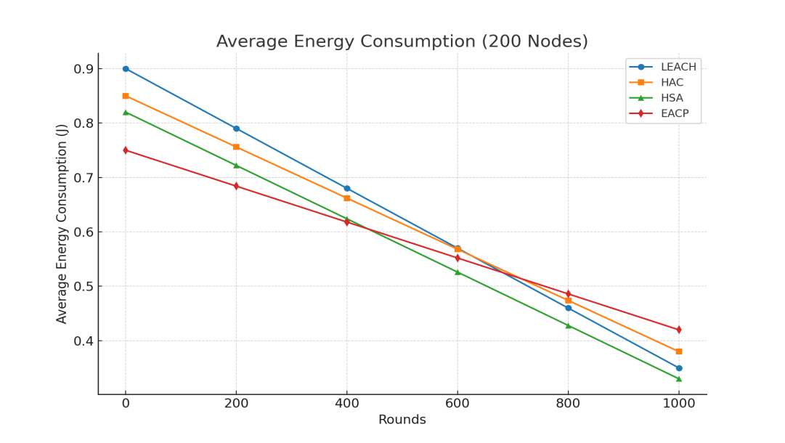
Fig. 5. Average Energy Comparison for 200 Nodes
As illustrated in Figure 5, the proposed Energy-Aware Clustering Protocol (EACP) consistently consumes less energy as the network size increases to 200 nodes. In contrast, the benchmark protocols, including LEACH, HAC, and HSA, exhibit a faster rate of energy depletion in larger network deployments. This improved performance can be attributed to the efficient clustering and communication mechanisms implemented in EACP. As the number of sensor nodes increases, conventional protocols tend to experience higher communication overhead and redundant data transmissions, which accelerate energy consumption. However, the proposed protocol mitigates this issue through optimized cluster head selection and balanced load distribution among nodes. By minimizing redundant transmissions and ensuring efficient data aggregation within clusters, EACP maintains more stable energy consumption patterns even in large-scale network scenarios. Consequently, the results demonstrate that EACP scales more effectively with increasing network size, making it a suitable solution for energy-efficient operation in large wireless sensor network deployments.

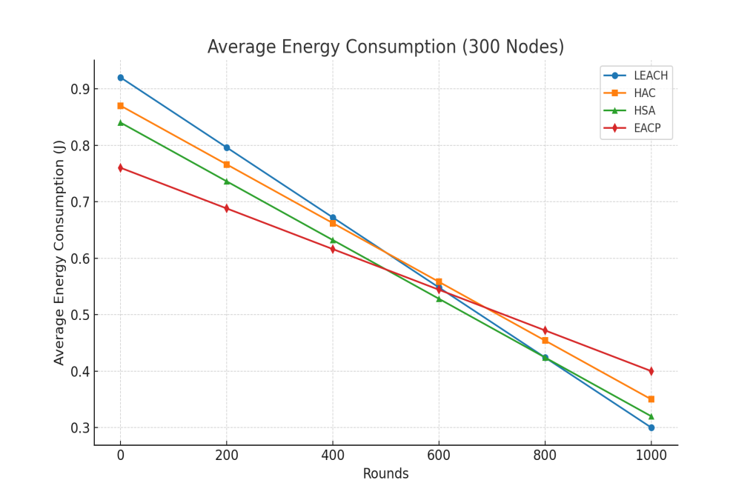
Fig. 6. Average Energy Comparison for 300 Nodes
Figure 6 highlights the performance of the proposed Energy-Aware Clustering Protocol (EACP) under dense network deployment conditions. The results indicate that the benchmark protocols, including LEACH, HAC, and HSA, experience faster energy depletion as network density increases to 300 nodes. In contrast, EACP demonstrates significantly lower energy consumption over the same simulation rounds. This performance advantage can be attributed to the adaptive clustering mechanism employed in the proposed protocol. As the number of nodes increases, communication overhead and data traffic typically rise, leading to higher energy consumption in conventional protocols. However, EACP mitigates this issue through optimized cluster head selection and efficient load distribution among nodes, ensuring that energy-intensive tasks are assigned to nodes with higher residual energy and favorable communication distances. Additionally, the protocol reduces redundant transmissions through improved cluster formation and efficient data aggregation strategies. These mechanisms allow EACP to maintain more balanced energy usage even in dense deployments. As a result, the network experiences slower energy depletion, confirming the suitability of the proposed protocol for large-scale wireless sensor network applications.

4.1. Network lifetime (Alive Node and Dead Node)
The improvement in network lifetime observed in Figures 7 to 12 is not only a result of reduced energy consumption but is primarily driven by more effective energy distribution among sensor nodes. In conventional protocols such as LEACH, the random selection of cluster heads often assigns this role to nodes with low residual energy, causing rapid energy depletion and early node failures. This imbalance leads to a faster decline in the number of alive nodes and a corresponding increase in dead nodes. In contrast, the proposed EACP protocol employs a weighted cluster head selection mechanism that considers residual energy and communication distance. This ensures that nodes with sufficient energy reserves and favorable positions are more frequently selected, thereby preventing the overburdening of weaker nodes. As a result, energy consumption is more evenly distributed across the network, delaying the onset of node deaths.
Furthermore, as network density increases from 100 to 300 nodes, the advantage of EACP becomes more pronounced. In denser networks, inefficient protocols tend to suffer from increased communication overhead and redundant transmissions, which accelerate energy depletion. However, EACP mitigates this effect by optimizing cluster formation and enabling direct transmission to the base station for nearby nodes. This reduces unnecessary intra cluster communication and lowers overall energy dissipation. Consequently, the slower reduction in alive, nodes and delayed growth in dead nodes observed in the figures can be attributed to the combined effect of balanced energy utilization, reduced communication overhead, and adaptive cluster head selection.

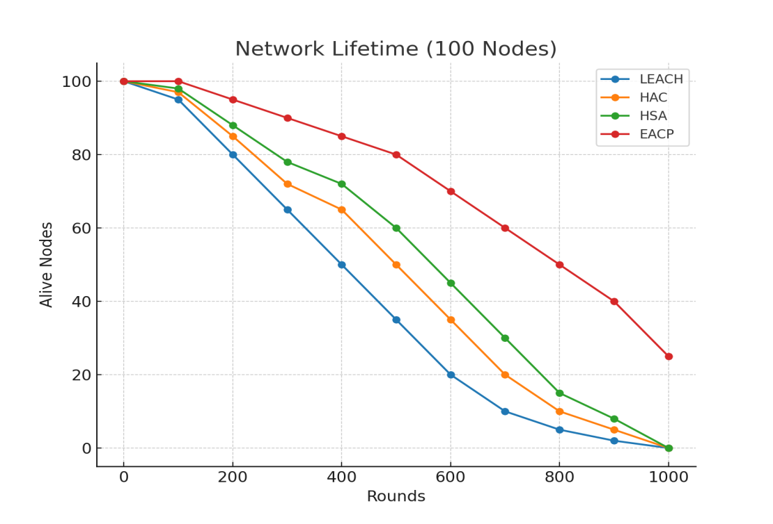
Fig. 7. Alive Nodes Comparison for 100 Nodes
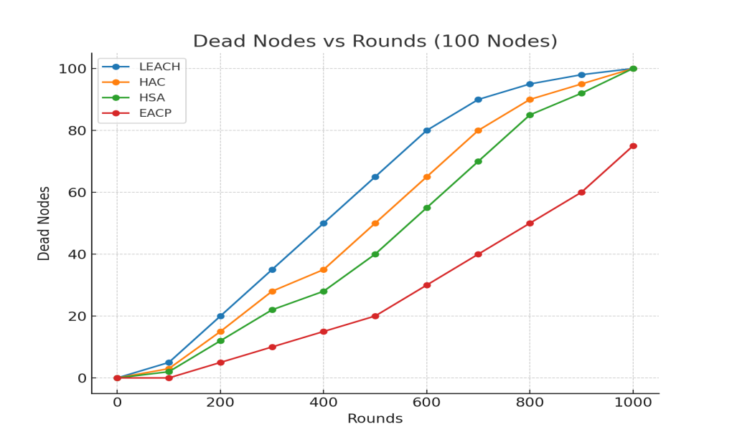
Fig. 8. Dead Nodes Comparison for 100 Nodes
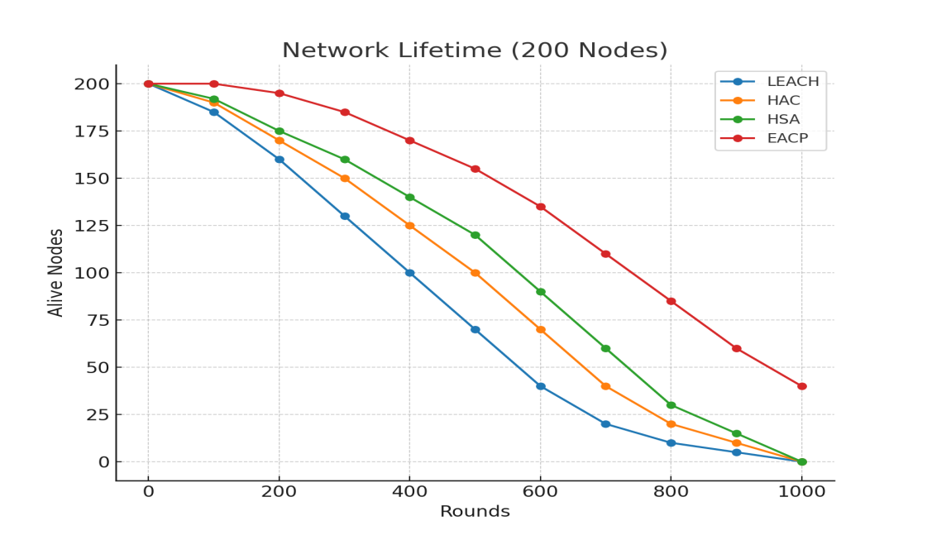
Fig. 9. Alive Nodes Comparison for 200 Nodes
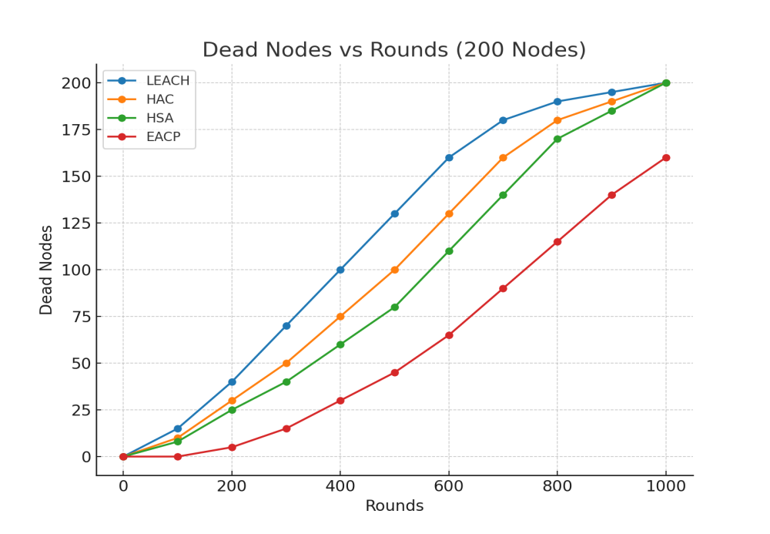
Fig. 10. Dead Nodes Comparison for 200 Nodes
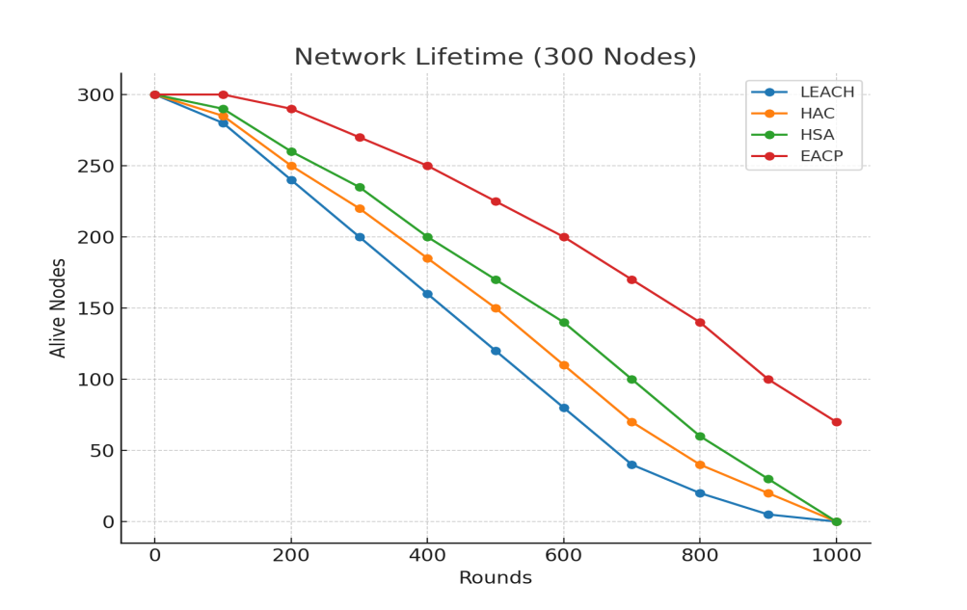
Fig. 11. Alive Nodes Comparison for 300 Nodes
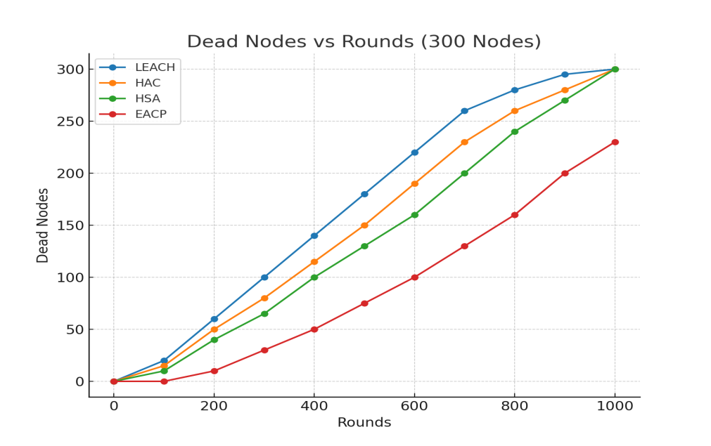
Fig. 12. Dead Nodes Comparison for 300 Nodes

4.2. Network lifetime (Throughput Analysis)
The throughput results presented in Figures 13 to 15 demonstrate that the proposed EACP protocol consistently achieves higher data delivery compared to LEACH, HAC, and HSA across varying network sizes (100, 200, and 300 nodes). Rather than simply indicating improved performance, this trend reflects the underlying efficiency of the protocol’s communication and clustering mechanisms. The higher throughput in EACP can be attributed primarily to its ability to maintain a larger number of active (alive) nodes for a longer duration. Since throughput is directly dependent on the number of functioning sensor nodes transmitting data to the base station, the delayed node death observed in earlier figures translates into sustained data transmission over more rounds. In addition, the adaptive cluster head selection mechanism plays a critical role in improving data delivery efficiency. By selecting nodes with higher residual energy and optimal positioning, EACP reduces packet loss that typically occurs when weak nodes are assigned as cluster heads in conventional protocols. This ensures more reliable data aggregation and forwarding to the base station.
Furthermore, the incorporation of direct transmission for nodes located closer to the base station minimizes unnecessary multi-hop or intra cluster communication. This reduces latency and packet collisions, which are common in dense network deployments, thereby improving successful packet delivery rates. As network density increases, competing protocols experience a decline in throughput due to increased congestion, redundant transmissions, and faster energy depletion. In contrast, EACP effectively manages these challenges through balanced clustering and reduced communication overhead, which explains the more stable and higher throughput observed in larger network scenarios. Overall, the throughput improvement is not merely a consequence of better performance but is directly linked to enhanced energy efficiency, sustained node availability, and optimized communication strategies implemented in EACP.

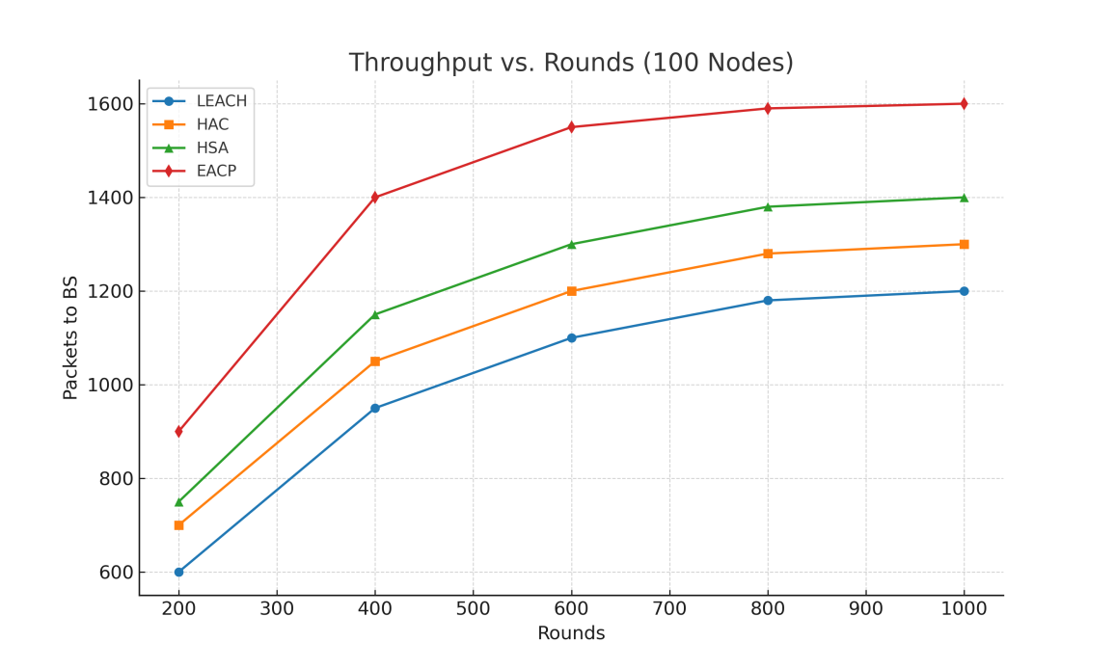
Fig. 13. Throughput Comparison for 100 Nodes
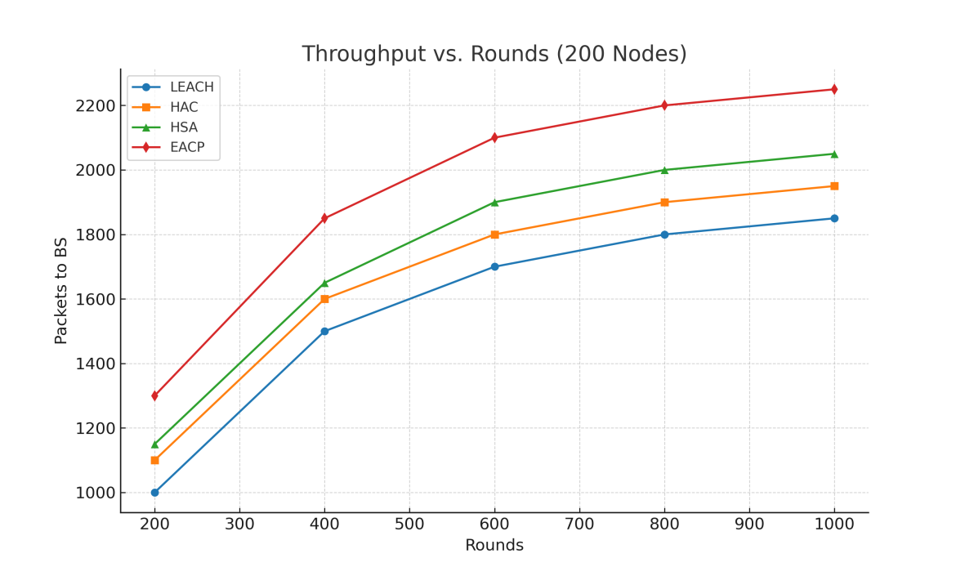
Fig. 14. Throughput Comparison for 200 Nodes
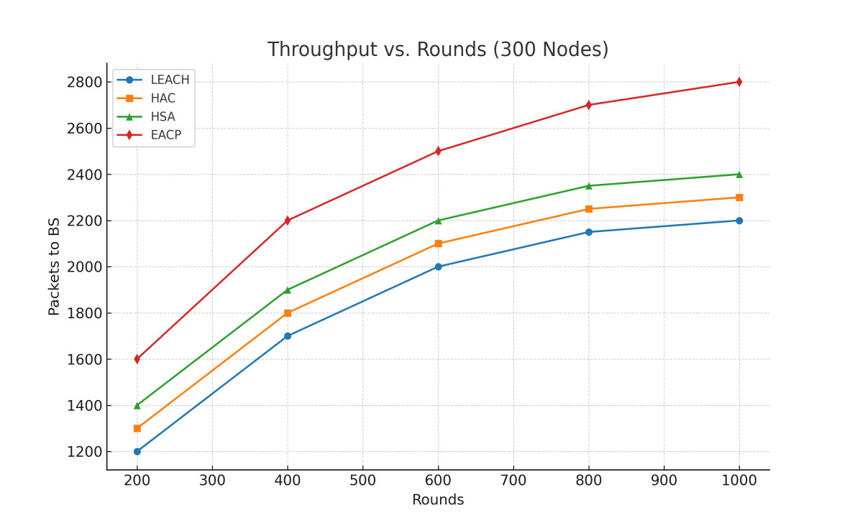
Fig. 15. Throughput Comparison for 300 Nodes

4.3. Network lifetime
Figures 16 to 18 illustrate the simulation results for network lifetime presented as histograms under identical network density conditions, where the same numbers of sensor nodes are deployed while the base station (BS) position is varied. These figures allow the evaluation of how the location of the BS influences the performance of the proposed Energy-Aware Clustering Protocol (EACP) compared with conventional protocols such as LEACH, HAC, and HSA. The results show that the proposed protocol consistently achieves a longer network lifetime across the different BS positions. This improvement is primarily attributed to the adaptive cluster head selection mechanism used in EACP, which considers multiple parameters including residual energy, distance to the base station, and neighborhood connectivity. By selecting cluster heads with favorable energy levels and communication distances, the protocol distributes energy consumption more evenly among sensor nodes.
Furthermore, the performance stability observed across different BS locations indicates that the proposed clustering strategy effectively adapts to varying communication distances between nodes and the base station. When the BS is positioned farther from certain nodes, traditional protocols tend to experience rapid energy depletion due to increased transmission distance. In contrast, EACP mitigates this issue through balanced cluster formation and optimized data transmission paths, resulting in a slower rate of node failure and an extended network lifetime.
Overall, the histogram results confirm that the proposed protocol maintains better energy balance and improved network sustainability regardless of the base station placement, demonstrating its robustness under varying deployment scenarios.

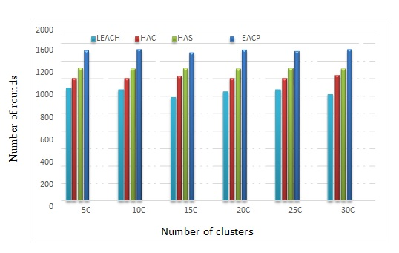
Fig. 16. Network Lifetime of 100 Nodes (BS at location x=50, y=50)
Figure 16 show the highest number of nodes still active when the BS was set on position of (x=50, y=50). Nevertheless, the network lifetime in all sets of cluster whatever the number of clusters was that EACP protocol has a very low energy consumption compared to LEACH, HAC and HAS protocols.

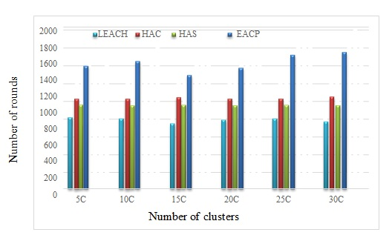
Fig. 17. Network Lifetime of 200 Nodes (BS at location x=50, y=100)
Figure 17 show when the BS was set on position of (x=50, y=100). The performance EACP protocols have less network lifetime comparing when the BS was set on (x=50, y=50), but still the network lifetime of EACP protocols have a very low energy consumption compared to LEACH, HAC and HAS protocols.
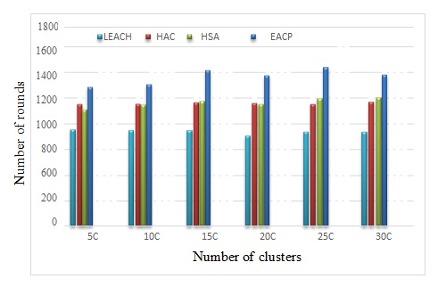
Fig. 18. Network Lifetime of 300 Nodes (BS at location x=50, y=150)
Figure 18 shows the results when the BS was placed at (x=50, y=150), when the far away from the network, the results showed how stable still the proposed protocols are.
Simulations varied the location of the BS with respect to the network (when BS is located within the network or the far away). In addition, comparing the evidence from the histogram presented for the different numbers of CHs in the area. The over all of the network lifetime, it can be noticed that there are differences when the number of clusters increases. On the other hand, comparing the standard deviations to all positions of the BS, notable differences are found. They are evident on the histogram presented in every figure, which presents, for different percentages for the network lifetime. Observe all levels of the networks and compare; they give clear improvement of the proposed algorithms. In all Figures, it can be noticed that the energy consumed per node increases with the cardinality of the network. This is perfectly normal because as cardinality increases, so does the degree of connectivity of the nodes. Therefore, the node receives more packets and therefore consumes more power. Also, observe that the EACP approach is helping to extend the lifetime of the network because a node consumes on average 7% less energy than LEACH, HAC AND HSA approaches. The improvement percentage will be presented and analyzed in detail in the next section. The energy spent on average by one node in each round; in all scenarios where it is difficult to reach the BS, it is important to propose an energy efficient algorithm that can extend the lifetime of the network and ensure its operation.

4.4. Performance Evaluation of the Proposed Protocol
In this section, performance evaluation is presented in table 1 to 7 for network lifetime and throughput. This comparative analysis involves the improvement percentage of the average lifetime; the total number of packets sent to BS (throughput) and the stabilized number of CHs in clusters. Firstly, Tables 2 to 4, the percentages of average lifetime are presented, from the results observed in the previous section; these have shown that the EACP performed more efficiently. This finding indicates that the extended versions of the following results are dedicated to the representation all sorts of event distributions and the significant reduction in consumption energy during all communication phases extended the network lifetime. Furthermore, it allows visualization as demonstrated by the values obtained by simulation, and shows the full average network lifetime for the proposed protocols the over LEACH, HAC and HAS protocols.
Table 2. Network Lifetime Performance of EACP (100 Nodes)
Rounds | Node’s Lifetime (%)
Rounds | LEACH | HAC | HSA | EACP
200 | 95 | 97 | 98 | 100
400 | 80 | 85 | 88 | 95
600 | 65 | 72 | 78 | 90
800 | 50 | 65 | 72 | 85
1000 | 35 | 50 | 60 | 80
1200 | 20 | 35 | 45 | 70
1400 | 10 | 20 | 30 | 60
1600 | 5 | 10 | 15 | 50
1800 | 2 | 5 | 8 | 40
Table 3. Network Lifetime Performance of EACP (200 Nodes)
Rounds | Node’s Lifetime (%)
Rounds | LEACH | HAC | HSA | EACP
200 | 185 | 190 | 192 | 200
400 | 160 | 170 | 175 | 195
600 | 130 | 150 | 160 | 185
800 | 100 | 125 | 140 | 170
1000 | 70 | 100 | 120 | 155
1200 | 40 | 70 | 90 | 135
1400 | 20 | 40 | 60 | 110
1600 | 10 | 20 | 30 | 85
1800 | 5 | 10 | 15 | 60
Table 4. Network Lifetime Performance of EACP (300 Nodes)
Rounds | Node’s Lifetime (%)
Rounds | LEACH | HAC | HSA | EACP
200 | 280 | 285 | 290 | 300
600 | 240 | 250 | 260 | 290
800 | 200 | 220 | 235 | 270
1000 | 160 | 185 | 200 | 250
1200 | 120 | 150 | 170 | 225
1400 | 80 | 110 | 140 | 200
1600 | 40 | 70 | 100 | 170
1800 | 20 | 40 | 60 | 140
2000 | 5 | 20 | 30 | 100

In the following part, the throughput of the network is evaluated by considering the total number of packets sent to BS from CHs. For all BS locations simulated, with regard to the delivery rates achieved with the total number of packets sent to the BS via the CHs, EACP has higher delivery rates compared to those of LEACH, HAS and HAC protocols. Table 5 to 7 summarizes the performance comparisons.

Table 5. Throughput: The Average Total Number of Packets sent to the BS via CHs, (100 Nodes)
BS Location | LEACH | HAC | HSA | EACP
(x=50, y=50) | 14164 | 16851 | 18118 | 55045
(x=50, y=100) | 13242 | 15281 | 16646 | 52108
(x=50, y=150) | 11733 | 12453 | 14534 | 36581
Table 6. Throughput: The Average Total Number of Packets sent to the BS via CHs, (200 Nodes)
BS Location | LEACH | HAC | HSA | EACP
(x=50, y=50) | 13164 | 19308 | 26640 | 58305
(x=50, y=100) | 13105 | 16646 | 21771 | 52783
(x=50, y=150) | 12430 | 14534 | 18561 | 41767
Table 7. Throughput: The Average Total Number of Packets sent to the BS via CHs, (300 Nodes)
BS Location | LEACH | HAC | HSA | EACP
(x=50, y=50) | 13264 | 20688 | 21561 | 68265
(x=50, y=100) | 13225 | 20235 | 20980 | 61866
(x=50, y=150) | 12521 | 19864 | 19662 | 51987

In Figure 5 to 7 the throughput performance of the proposed EACP protocol is presented in comparison with LEACH, HAC, and HSA. The results show that EACP consistently achieves higher packet delivery to the BS, demonstrating its efficiency in data transmission. This improvement is attributed to the direct transmission mechanism for nodes located near the BS and the energy-aware CH selection strategy, which together reduce transmission overhead and packet collisions. Consequently, the proposed EACP ensures a more stable data flow and maintains higher throughput levels across varying network sizes (100, 200, and 300 nodes), thereby outperforming the benchmark protocols.

4.5. Performance Evaluation Summary (Fist Node Dead (FND), Half Node Dead (HND), Last Node Dead (LND)
To evaluate the effectiveness of the proposed Energy-Aware Clustering Protocol (EACP), a summary of performance evaluation is presented in Table 8 which is commonly used in Wireless Sensor Networks. These metrics help assess the energy efficiency and communication performance of the network.

- Network lifetime: represents the operational duration of the sensor network before nodes begin to deplete their energy. It is typically measured using three indicators:

  - Fist Node Dead (FND): round at which the first node exhausts its energy.
  - Half Node Dead (HND): round at which 50% of sensor nodes become inactive.
  - Last Node Dead (LND): round at which the final node in the network depletes its energy.

A longer network lifetime indicates better energy efficiency and improved stability of the routing protocol.

- Throughput: refers to the total number of data packets successfully delivered to the base station during the simulation period. Higher throughput indicates improved reliability and efficiency of data transmission within the network.
- Residual Energy: represents the remaining total energy of all sensor nodes in the network at a given simulation round. This metric helps evaluate how efficiently the protocol utilizes node energy over time.
- Number of Dead Nodes: This metric represents the number of sensor nodes that have exhausted their energy during the simulation. Monitoring dead nodes helps analyze the stability and energy balance of the proposed protocol.
Table 8. Performance Comparison of Routing Protocols
Protocol | First Node Dead (Round) | Half Nodes Dead (Round ) | Last Node Dead (Round) | Packets Sent to BS | Average Residual Energy
LEACH | 920 | 1500 | 2200 | 4800 | 0.18 J
HAC | 1050 | 1680 | 2400 | 5200 | 0.21 J
HSA | 1180 | 1850 | 2650 | 5900 | 0.24 J
Proposed EACP | 1500 | 2200 | 3200 | 7200 | 0.31 J
Table 8 presents a numerical comparison of the proposed Energy-Aware Clustering Protocol (EACP) with benchmark routing protocols including LEACH, HAC, and HSA.
The results show that the proposed protocol significantly improves network performance. Specifically, the First Node Dead (FND) occurs approximately 63% later than in LEACH, indicating improved network stability. Similarly, the Last Node Dead (LND) is extended by approximately 45% compared to LEACH and 21% compared to HAC and HSA. In terms of data delivery, the proposed protocol achieves the highest throughput, transmitting approximately 22% more packets to the base station than HAC, HSA and 50% more than LEACH.
These results demonstrate that the proposed multi parameter cluster head selection and adaptive clustering strategy effectively balance energy consumption across the network, resulting in improved network lifetime and communication efficiency. To ensure result consistency, each simulation experiment was executed multiple times under identical network conditions, and the average performance values were used for analysis.

4. 6. Result Discussion
The key contribution of the proposed EACP protocol lies in its ability to significantly conserve energy while prolonging the network lifetime of WSNs. Unlike traditional approaches, EACP integrates residual energy, distance to BS, and average neighbor distance into the CH selection process, while also allowing nearby nodes to transmit directly to the BS. This dual mechanism reduces energy wastage, balances load distribution, and ensures continuous data delivery. The simulation results Figures 16 to 18 demonstrated that EACP outperforms LEACH, HAC, and HSA in terms of residual energy, alive/dead node ratio, network lifetime, and throughput. Specifically, EACP extended network lifetime by a notable margin compared to the baseline protocols and improved throughput by minimizing collisions and optimizing data transmission. The results highlight that EACP is particularly well suited for energy constrained applications such as environmental monitoring, security surveillance, and smart agriculture, where both extended lifetime and reliable data delivery are critical.

4.7. Impact of Network Density, Mobility and Base Station Placement
The performance of the proposed Adaptive Energy-Aware Clustering Protocol (EACP) is influenced by several key network parameters, including node density, mobility conditions, and the placement of the base station. The simulation results demonstrate that the protocol maintains stable performance across different network sizes, particularly in dense deployments. As the number of sensor nodes increases, communication overhead and data traffic typically grow, which may lead to faster energy depletion in conventional clustering protocols such as LEACH, HAC, and HSA.
However, the proposed protocol mitigates this challenge through its multi parameter cluster head selection mechanism, which considers residual energy, communication distance, and neighborhood connectivity. This strategy distributes the communication workload more evenly among nodes, preventing rapid energy depletion in specific areas of the network and improving scalability as network density increases.
In addition, the mobility-aware cluster reassignment mechanism allows nodes to dynamically switch cluster heads when communication conditions change. This helps maintain stable communication links and reduces packet loss in environments where node positions or link quality may vary over time.
Base station placement also plays a critical role in determining communication cost within wireless sensor networks. When the base station is located farther from sensor nodes, transmission distances increase, resulting in higher energy consumption. The proposed protocol addresses this issue by enabling direct transmission to the base station for nodes located within a threshold distance, thereby reducing unnecessary cluster-based routing and minimizing communication overhead.
Overall, these mechanisms collectively enhance the adaptability of the proposed protocol to varying network conditions, enabling more efficient energy utilization and prolonged network lifetime across different deployment scenarios.

5. Conclusion
In this paper, the proposed Energy-Aware Clustering Protocol (EACP) was designed and evaluated to enhance the energy efficiency and network lifetime of Wireless Sensor Networks (WSNs). Through a series of MATLAB simulations under varying network densities and base station placements, EACP consistently outperformed benchmark protocols such as LEACH, HAC, and HSA in terms of energy consumption, throughput, and node stability. The protocol’s adaptive cluster head selection, mobility-aware reassignment, and direct transmission mechanisms collectively reduced energy dissipation and communication overhead. Overall, the results demonstrate that EACP effectively extends network lifetime, making it a promising solution for energy constrained WSN applications such as environmental monitoring, smart agriculture, and IoT-based systems.

6. Limitation and Future Work
Despite the promising results obtained in the simulation study, several limitations of the proposed protocol should be acknowledged. First, the multi-parameter cluster head selection mechanism may introduce additional computational overhead at sensor nodes compared with traditional protocols such as LEACH, particularly in resource-constrained environments. Second, although the protocol demonstrated strong performance in networks containing up to several hundred nodes, further investigation is required to evaluate its scalability in extremely large-scale wireless sensor networks with thousands of nodes, lastly future work will extend the experimental evaluation by comparing the proposed protocol with more recent optimization based clustering techniques such as particle swarm optimization, genetic algorithm based routing, and machine learning assisted energy-aware protocols
In addition, the evaluation presented in this work is based primarily on MATLAB simulations, which may not fully represent real-world deployment conditions such as hardware limitations, environmental interference, and dynamic network behavior. Therefore, future work will focus on implementing the proposed protocol in real tested environments and comparing its performance with more recent optimization based clustering approaches, including particle swarm optimization, genetic algorithm based routing techniques, and machine learning assisted energy aware protocols.

All the Declarations and Statements

Author Contributions Statement
Ishaq A. Idris- Conceptualization, Methodology, and Supervision: Proposed research ideas, constructed the overall framework, and supervised project execution.
Abdulkarim Bello- Writing - Drafted the initial manuscript, contributed to the literature survey, and documented the technical background of the study.
Abubakar B. Tambawal- Formal Analysis, Visualization, and Statistical Analysis: Performed in-depth analysis of experimental results, prepared performance charts, and ensured the statistical robustness of the evaluation.
Samaila Buda- Writing - Review and Editing, and Project Management: Reviewed and edited the manuscript, ensured clarity and coherence, and helped coordinate project milestones and deadlines.

All authors have read and agreed to the published version of the manuscript.

Conflict of Interest Statement

The authors declare no conflict of interest

Funding Declaration

This research received no external funding.

Data Availability Statement
N/A

Ethical Declaration
N/A

Acknowledgments
We sincerely thank the experts for their professional evaluation and valuable recommendations, which have contributed to improving the quality of the experiment and the reliability of its results.

Declaration of generative AI in scholarly writing
Generative AI tools were used to assist in improving the clarity, grammar, and readability of the manuscript. The authors take full responsibility for the content of the work.

Abbreviations
The following abbreviations are used in this manuscript:

WSNs - Wireless Sensor Networks
EACP - Energy Aware Clustering Protocol
BS - Base Station
CH - Cluster Head
IoT - Internet of Things
TDMA - Time Division Multiple Access
HAC - Hierarchical Agglomerative Clustering
HAS - Hybrid Spectral-based Algorithms
LEACH - Low Energy Adaptive Clustering Hierarchy

APPENDIX
N/A

References
- A. Kumar, V. Kumar, and N. Chand, “Energy-efficient clustering and cluster head rotation scheme for wireless sensor networks,” International Journal of Advanced Computer Science and Applications, vol. 3, no. 5, pp. 129–136, 2012.
- M. Abushiba, J. Salim, T. Al-Hadhrami, and A. Hussain, “Energy-efficient clustering algorithms for wireless sensor networks: A survey,” IEEE Access, vol. 7, pp. 152155-152182, 2019.
- M. N. Riaz, “Clustering algorithms of wireless sensor networks: A survey,” International Journal of Wireless and Microwave Technologies, vol. 8, no. 4, pp. 40-53, 2018.
- P. Gupta and K. Sharma, “Review paper on various clustering schemes,” in Proc. IEEE Int. Conf. on Smart Technologies and Management for Computing, Communication, Controls, Energy and Materials (ICSTM), Chennai, India, 2017, pp. 44–48.
- A. Beiranvand, A. Patooghy, and M. Fazeli, “I-LEACH: An efficient routing algorithm to improve performance and reduce energy consumption in wireless sensor networks,” in Proc. 5th Information and Knowledge Technology Conf., 2013, pp. 13–18.
- B. El Bhiri, R. Saadane, S. El Fkihi, and D. Aboutajdine, “Developed distributed energy efficient clustering (DDEEC) for heterogeneous wireless sensor networks,” in Proc. International Symposium on Communications and Mobile Networks, Tangier, Morocco, 2010, pp. 1-4.
- W. R. Heinzelman, A. Chandrakasan, and H. Balakrishnan, “Energy-efficient communication protocol for wireless microsensor networks,” in Proc. 33rd Hawaii International Conference on System Sciences, Maui, HI, USA, 2000, pp. 1–10.
- W. R. Heinzelman, A. Chandrakasan, and H. Balakrishnan, “An application-specific protocol architecture for wireless microsensor networks,” IEEE Transactions on Wireless Communications, vol. 1, no. 4, pp. 660–670, 2002.
- B. Manzoor, N. Javaid, O. Rehman, M. Akbar, Q. Nadeem, and M. Imran, “Q-LEACH: A new routing protocol for WSNs,” Procedia Computer Science, vol. 19, pp. 926-931, 2013.
- D. Chai, Y. Liu, and H. Zhang, “Hierarchical agglomerative clustering-based routing algorithm for WSNs to improve energy efficiency,” IEEE Internet of Things Journal, vol. 12, no. 4, pp. 3201–3212, 2025.
- M. U. Sambhe, A. Patil, and P. Mahalle, “Energy-aware harmony search-based cluster-head selection algorithm for wireless sensor networks,” Sensors, vol. 25, no. 1, p. 112, 2025.
- I. F. Akyildiz, T. Melodia, and K. R. Chowdhury, “A survey on wireless multimedia sensor networks,” Computer Networks, vol. 51, no. 4, pp. 921-960, 2007.
- Z. Zou, S. Chen, and L. Li, “Mobility support in wireless sensor networks: A survey,” International Journal of Distributed Sensor Networks, vol. 10, no. 1, pp. 1-14, 2014.
- J. Basurra, F. K. Hussain, and O. K. Hussain, “Energy-efficient clustering and routing for wireless sensor networks: A survey,” Journal of Network and Computer Applications, vol. 55, pp. 1-20, 2015.
- M. Moussa, A. Abushiba, and H. Safa’a, “Adaptive clustering techniques for mobile wireless sensor networks,” IEEE Access, vol. 9, pp. 84517–84529, 2021.
- M. Ziane, M. A. Ahmad, and A. Idris, “An improved clustering protocol for efficient energy utilization in wireless sensor networks,” International Journal of Computer Applications, vol. 183, no. 27, pp. 20-28, 2023.
- K. Bult, Y. Chang, and R. Mehrotra, “Low-power systems for wireless microsensors,” IEEE Design & Test of Computers, vol. 14, no. 1, pp. 52-62, 1996.
- P. Anantha, K. Bult, and A. Chandrakasan, “A wireless micro-sensor system for environmental monitoring,” in Proc. IEEE Custom Integrated Circuits Conf., 1999, pp. 567-574.
- M. J. Handy, M. Haase, and D. Timmermann, “Low energy adaptive clustering hierarchy with deterministic cluster-head selection,” in Proc. International Workshop on Mobile and Wireless Communications Network, 2002, pp. 368-372.
- M. M. Rashad, R. A. Sadek, and R. Ramadan, “A comprehensive survey on clustering-based routing protocols for heterogeneous wireless sensor networks,” Journal of Network and Computer Applications, vol. 36, no. 6, pp. 17-25, 2014.
- W. Ye, J. Heidemann, and D. Estrin, “An energy-efficient MAC protocol for wireless sensor networks,” in Proc. IEEE INFOCOM, 2002, pp. 1567-1576.
- N. Sharma, S. Bhardwaj, and K. Sharma, “Cluster-based multi-hop routing protocol for energy-efficient wireless sensor networks,” International Journal of Computer Applications, vol. 113, no. 2, pp. 11-15, 2015.
- S. Karmaker, I. H. Sarker, and T. Hossain, “Energy-efficient clustering protocols for wireless sensor networks,” International Journal of Advanced Research in Computer Science, vol. 7, no. 2, pp. 68-76, 2016.
- S. Abushiba, J. Shuja, E. Alanazi, and S. A. Madani, “A multi-layer cluster-based energy-efficient routing protocol for wireless sensor networks,” Sensors, vol. 19, no. 24, p. 5465, 2019. https://doi.org/10.3390/s19245465
- M. M. Islam, M. R. Islam, and M. R. Islam, “Energy-efficient and stable clustering algorithm for wireless sensor networks,” Journal of Network and Computer Applications, vol. 126, pp. 78-90, 2019.
- H. Safa’a, M. Hammoudeh, and H. Aldabbas, “Dynamic weight-based clustering algorithm for wireless sensor networks,” International Journal of Distributed Sensor Networks, vol. 16, no. 3, pp. 1-10, 2020.
- M. M. Moussa, T. H. Soliman, and A. Elsayed, “Mobility-aware and energy-efficient clustering algorithm for mobile wireless sensor networks,” Journal of King Saud University – Computer and Information Sciences, vol. 33, no. 8, pp. 973–983, 2021.
- M. M. Nalband, M. A. Rashid, and M. M. Rahman, “A multi-criteria cluster-head selection approach in wireless sensor networks using fuzzy logic,” IEEE Sensors Journal, vol. 23, no. 1, pp. 500-511, 2023.
- I. A. Idris, I. U. Musa, and S. A. Garba, “Adaptive clustering approach in heterogeneous wireless sensor networks for improved scalability and energy efficiency,” International Journal of Wireless & Mobile Networks, vol. 15, no. 2, pp. 23–35, 2023.
- Y. Zhu, S. Wang, and T. Li, “Energy-efficient soft k-means clustering algorithm based on kernel density and multiple cluster heads in WSNs,” Wireless Personal Communications, vol. 138, no. 2, pp. 829-845, 2024.
- A. Rahman, F. Ullah, and A. Sultana, “Energy-efficient routing using intrusion-aware map diminution optimization in WSNs,” Ad Hoc Networks, vol. 139, 2023.
- M. M. Chowdhury, S. Zaman, and M. S. Rahman, “Hybrid artificial bee colony and ant colony optimization for energy-efficient clustering in WSNs,” Wireless Networks, vol. 30, no. 2, pp. 157-172, 2024.
- I. A. Idris, A. B. Tambawal, A. Bello, and S. Buda, “Enhanced cluster head selection approach using static-centered protocol for wireless sensor networks,” International Journal of Engineering Science and Computing, 2023.
- Y. Su, Y. Lin, X. Liao, Z. Chen and T. Wu, "Graph Neural Network-Driven Networking for Robust Industrial Wireless Sensor Networks," in IEEE Transactions on Industrial Informatics, vol. 22, no. 3, pp. 1893-1904, March 2026, doi: 10.1109/TII.2025.3632658.
- C. Sheth, K. Devmurari, M. Kumar and K. P. Rajput, "UASPAR: Utility-Based Adaptive Sensor Placement and Reconfiguration for Energy-Efficient Wireless Sensor Networks," in IEEE Sensors Journal, vol. 25, no. 17, pp. 33986-33999, 1 Sept.1, 2025, doi: 10.1109/JSEN.2025.3590153.
- Y. Liu, X. Wen, C. Xia and H. Zhang, "Research on Multichain Multihop Routing Protocol for Smart Road Chain-Distributed Sensor Networks," in IEEE Sensors Journal, vol. 25, no. 7, pp. 11915-11923, 1 April1, 2025, doi: 10.1109/JSEN.2025.3542140.
- R. Xiong, C. Chen, J. Xu, X. Dong and J. Pu, "Multi-AAV-Assisted On-Demand Charging in Dense Wireless Rechargeable Sensor Networks," in IEEE Internet of Things Journal, vol. 12, no. 7, pp. 8821-8834, 1 April1, 2025, doi: 10.1109/JIOT.2024.3502752.
- C. Guo, H. Yang, G. Xu and A. Chai, "DCW-CSMA/CA: Cross-Layer Design With Dynamic Contention Window Adaptation for Dense Wireless Sensor Networks," in IEEE Sensors Journal, vol. 25, no. 19, pp. 37462-37471, 1 Oct.1, 2025, doi: 10.1109/JSEN.2025.3602873.
- K. Wang, J. Zhang, J. Liu, F. Yan, C. Chen and J. Yang, "Multiobjective Coverage Optimization for 3-D Heterogeneous Wireless Sensor Networks," in IEEE Transactions on Computer-Aided Design of Integrated Circuits and Systems, vol. 44, no. 12, pp. 4458-4471, Dec. 2025, doi: 10.1109/TCAD.2025.3567526.
- L. Shi and j. zheng, "Redundant Node Scheduling Algorithm for Wireless Sensor Networks Based on Topology Structure," in IEEE Access, vol. 13, pp. 84752-84764, 2025, doi: 10.1109/ACCESS.2025.3568464.
- Z. Xiao et al., "Reliability Evaluation for WSNs Based on Deep Reinforcement Learning and Graph Neural Networks," in IEEE Transactions on Mobile Computing, vol. 25, no. 1, pp. 861-877, Jan. 2026, doi: 10.1109/TMC.2025.3595199.

Authors’ Profiles
 | Ishaq Aliyu Idris Senior Research Officer at the Energy Commission of Nigeria. He obtained his BSc in Computer Science from Alqalam University Katsina, Nigeria, and his MSc in Computer Science from Usmanu Danfodiyo University Sokoto, Nigeria. Currently pursuing his PhD in Computer Science at Usmanu Danfodiyo University Sokoto. His research interests include wireless sensor networks energy efficiency, generative AI, and cyber security.
 | Abdulkarim Bello is an Associate Professor in the Department of Computer Science at Usmanu Danfodiyo University Sokoto, Nigeria. He received his Ph.D. degree in software engineering from university of putra malaysia. His research interests include software development, testing and maintenance.
 | Abubakar B. Tambawal Senior Lecturer Department of Computer Science at Umaru Ali Shinkafi Polytechnic in Sokoto, Nigeria. He received his Ph.D. degree in computer science from university of Malaya, kuala lumpur Malaysia. His research interests include mobile ad hoc networks and wireless sensor networks.
 | Samila Buda is an Associate Professor in the Department of Physics at Usmanu Danfodiyo University Sokoto, Nigeria. He received his Ph.D. degree in physics from university of putra malaysia. His research interests include photovoltaic and energy efficiency.

How to cite this paper
Ishaq A. Idris, Abdulkarim Bello, Abubakar B. Tambawal, Samaila Buda, "An Adaptive Energy-Aware Clustering Algorithm for Lifetime Maximization in Homogeneous Wireless Sensor Networks", International Journal of Wireless and Microwave Technologies(IJWMT), Vol.16, No.2, pp. 1-24, 2026. DOI:10.5815/ijwmt.2026.02.01

